Static Code Analysis Process Summary
Singh Parminder
This summary compares the issues identified in QuestionableCode.cpp using Visual Studio build/code analysis and Cppcheck-style static analysis. The goal was to identify coding risks, compare tool findings, and explain practical mitigations before release.
Tool Comparison
Compiler and code-analysis warnings that were recently discovered by Visual Studio, including unused variables, variable shadowing, assignment inside an assert expression, throwing from a noexcept function They provide value because they highlight mistakes that can lead to differing debug and release behavior, or decreased maintainability.
Cppcheck findings showing some of the deeper static-analysis risks that may otherwise be missed by a compiler. These consisted of boundless recursion, out-of-bounds access to an array, return a pointer to the local variable, iterator probably invalidated after vector::erase (and lots of reasons for this) an empty while loop than suspect that will jump into never-ending loops and pointer dereferencing null. These are more dangerous findings as they can do things like cause crashes, stack overflow, memory corruption and provide you with undefined behavior.

Issues, Risk, and Mitigation
- Cppcheck - RISK - Endless recursion in C::is_type: call itself with same argument and changes no state. If consumed, can lead to stack overflow. Mitigation: always return true when the type is found or else redesign the recursion around a proper base case.
- For example, in Cppcheck RISK — Out of bound write to buf[1000], it indicates that the array only has ten elements (from 0-9), and writing to index 1000 will corrupt memory. Mitigation: Either validate count against the size of the array or, whenever possible, use std::array/std::vector with bounds checking.
- Cppcheck - RISK - Dangling pointer in foo(int): The function saves the address of local variable b into the caller pointer. After return from the function, this address becomes invalid. Mitigate: return a value, use caller owned storage or smart pointers only if the semantics require it.
- Cppcheck — RISK — vector_test: invalidation of iterator; in erase iter is invalidated, but the loop increments and uses it again Mitigation: assign iter = items. erase(iter) or break after erasing.
- Cppcheck — RISK: Empty while statement and null pointer dereference: while(tok); has empty body. At that point tok is null, and tok->next() dereferences a null pointer. Mitigation: delete the rogue semicolon and validate tok before dereferencing.
- Visual Studio and Cppcheck - RISK - assert(z =2) which uses assignment instead of comparison. The behavior is different because assert calls are removed in release builds. Mitigation: def use assert(z == 2) or assign before the assert and test separately.
- Visual Studio and Cppcheck - RISK - 'throwing from noexcept' in DontThrow: An exception was thrown from within a noexcept function, which subsequently may call std::terminate. Mitigation: remove noexcept or handle condition without throwing.
- Cppcheck/compiler warning — RISK — my_function returns bool but is compared with 3: A bool can only be either true or false, so the comparison constitutes a logic error. Fix: return int(0) if num-value matters OR compare the bool with true/false
- Visual Studio & Cppcheck - NOT RISK - Unused variables and dead code: counts, x, y and do_something_useless are blacklisted. This does not directly open up a security vulnerability, but it decreases readability. Mitigation: get rid of unused code or use it deliberately.
- Visual Studio + Cppcheck- NOT RISK Variable shadowing inner x, y and z hides outer variables. This can cause maintenance bugs. Mitigation: Opt for descriptive names or reduce scope of variables.

Recommended Correction Order
Memory and control-flow defects are high priority for fixes: fix array bounds, remove dangling pointer, iterator handling, empty while-loop semicolon, null pointer dereference. Then fix logic errors like assert(z == 2), the improper bool-to-integer comparison, and the noexcept thrown. Lastly delete unused variables and shadowed variables to make it more readable.

Visual Studio Error List Screenshot
The screenshot below, which I exported to Excel, represents the Visual Studio Error List messages for the supplied file. In a local Visual Studio environment, this image can be replaced with a direct screenshot from the IDE after building the project and running code analysis.
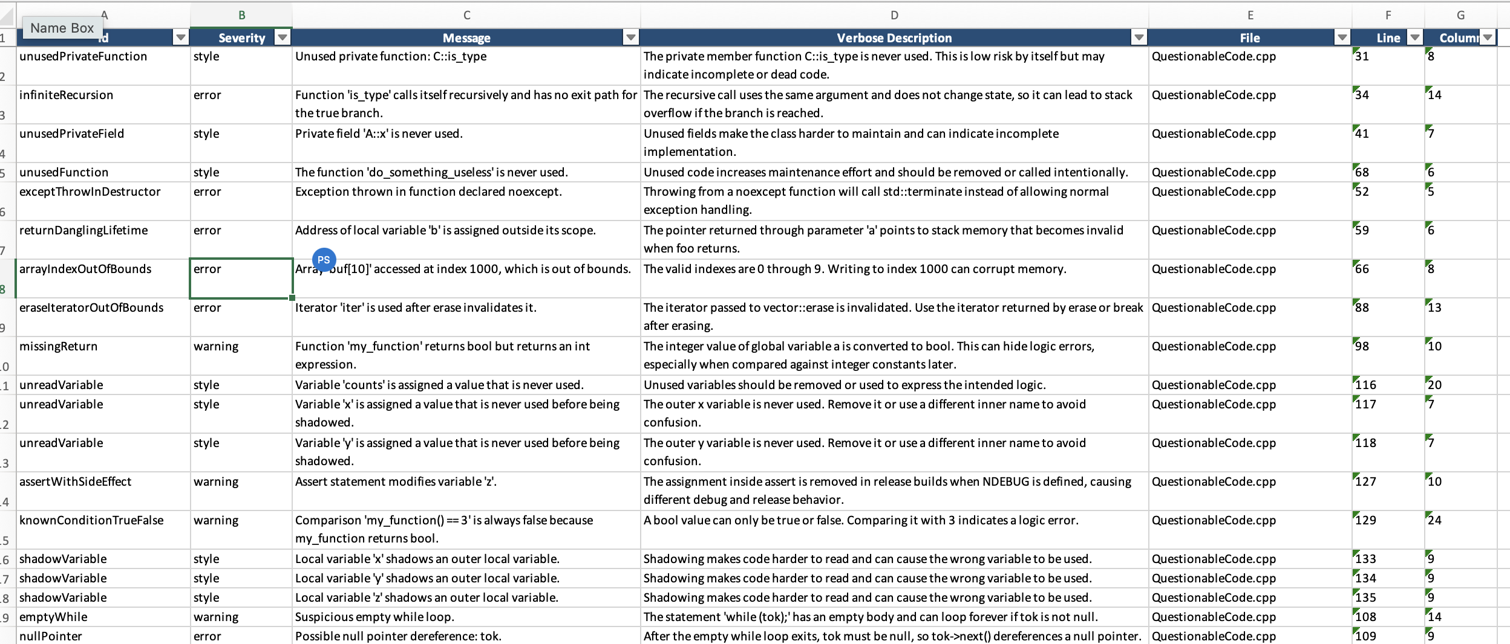
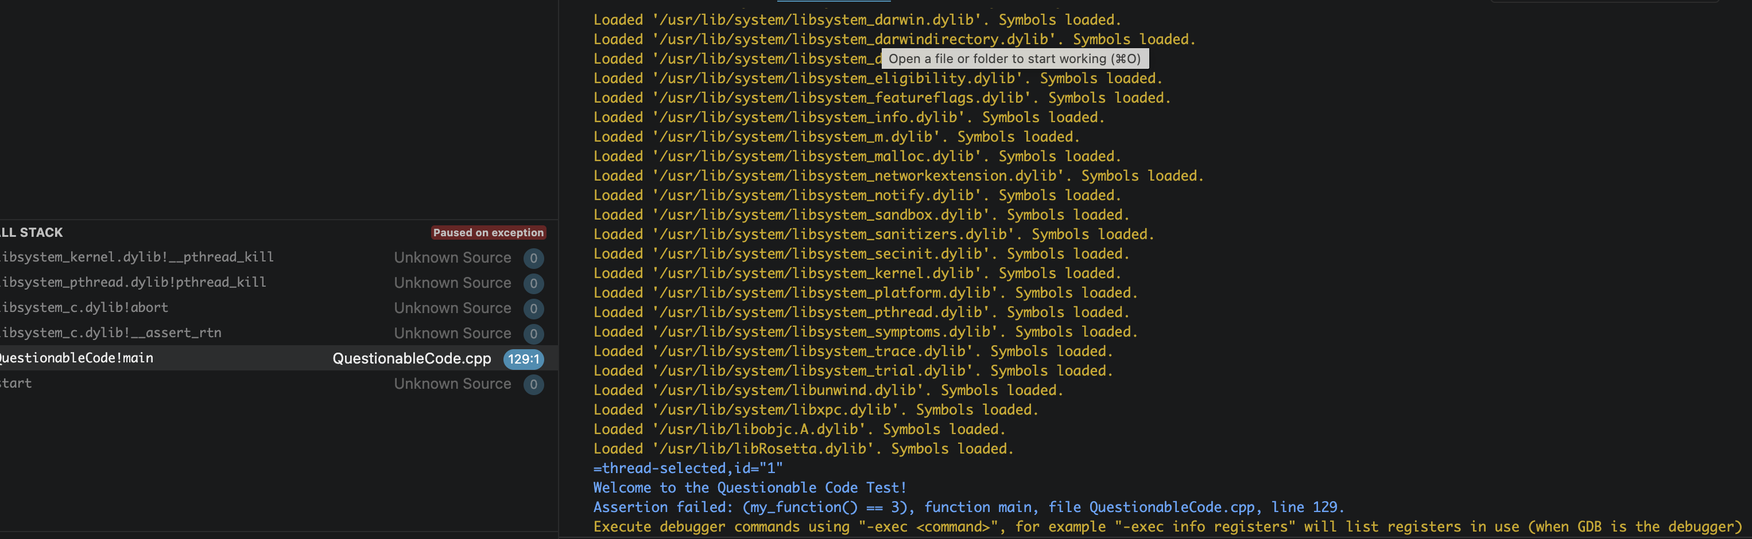
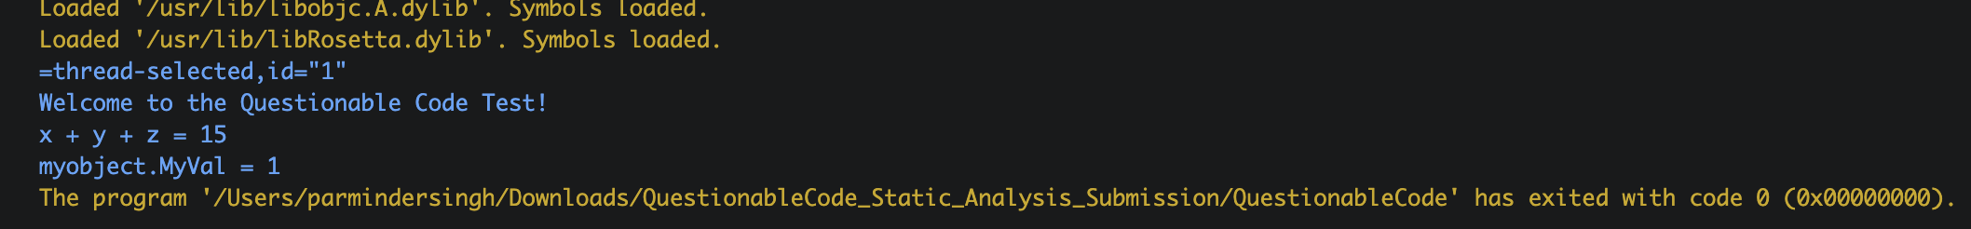
Conclusion
The comparison exemplifies the importance of combining static analysis tools. Visual Studio is very well known for its compiler and code-quality warnings while Cppcheck proves to be more useful to catch some logic, memory, and control-flow defects. Collectively, they give a more resilient layer for vulnerability resolution, allowing developers to fix vulnerabilities in the early stages of software development.

